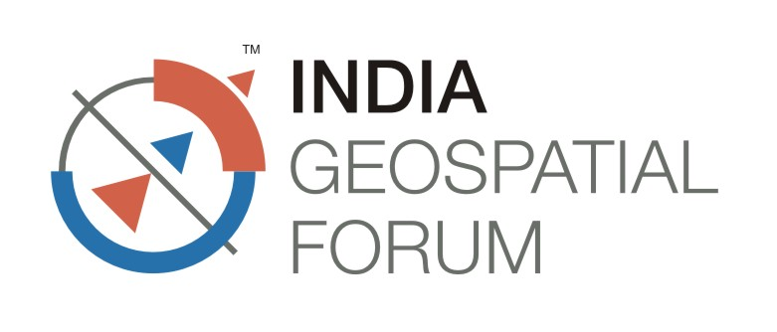
5th – 7th February 2014
HICC, Hyderabad, Andhra Pradesh
Company Information Form  (Compulsory for all Exhibitors) | Return this form to :  Geospatial Media and Communications  A-145, Sec-63, Noida-201301, India  Tel: +91-120-4612500, Fax: +91-120-4612555/666  tarun@geospatialmedia.net

Please fill the following company Profile Information Last date: 5th January 2014

Company Name:

Company Address:

City/Stage:

Country:

Zip Code/Pin Code:

Contact Person:

Position:

Telephone:

Fax:

E-Mail:

Date:

Company Website:

Profile Write-up (Not more then 100words)

Please attach separate Sheet(typed) if required.
Please E-mail your company information on above mentioned contact details by 5th January 2014.

